QUOTATION
DATE |  | EXPIRATION DATE |  |  |  | REVISION/VERSION
04/03/2023 |  | 03/04/2023 |  |  |  | 1
FROM: Shedmate Sample |  |  | TO: Artur Bessoni
2/2A  Hammer Ct,  Mount Gambier South Australia 5290 |  |  | 7 Bamburgh Street Derrimut Victoria Australia 3026
Phone: 0476122076  Email: shedmate@shedmate.com.au  Website: www.shedmate.com.au |  |  | Phone: 476122076  E-mail: artur@shedmate.com.au
Shedmate Sample appreciates the opportunity to provide you with a quotation for your new building. Please find below all project information, details, specifications, inclusions, exclusions, plans, terms and conditions and payment details.

This proposal is valid until 03/04/2023 and is subject to the site classification and engineering data. We look forward to being of assistance to you.

Anything that has been discussed or implied that is not detailed in this quote has not been allowed for in the quote price. If you require anything extra, please contact us and we will send you a revised quotation.
PROJECT INFORMATION AND SITE LOCATION
Project Name | BESSONI-ARTUR-10-C-SHED-2-2023
Site Address | 7 Bamburgh Street Derrimut Victoria 3026
Council | City of Brimbank
Coordinates | -37.782974,144.7584
Responsible | Artur Bessoni
BUILDING SPECIFICATIONS
Span Width | 7500mm
Length | 12000mm
No of Bays | 4
Height | 3000mm
Roof Type and Material | Gable End – Trimdek Basalt
Roof Pitch | 12
External Walls and Trim Material | Trimdek Evening Haze
Insulation | Roof – None  Side Walls – None  End Walls – None
Roller Doors | Roller Door: Ironstone Series A: 2600(W)x2600(H)mm (2x)
Roller Door Motors
PA Doors | PA Door: Ironstone: 820(W)x2040(H)mm (1x)
Windows | Window Glass: Ultra Silver: 1500(W)x1200(H)mm (1x)
Glass Doors | Door Glass: Ultra Silver: 1800(W)x2100(H)mm (1x)
Sliding Doors | Sliding Panel: Evening Haze: 3125(W)x2783(H)mm (2x)
Open Bays | Bay Opening: 3753.5(W)x3798(H)mm (1x)
Skylights | LaserLite 2000: Skylight Greca Grey 3889 m (2x)
Spin Aways | Spin Aways: Spin Away: Ironstone (2x)
Gutters | Square Fascia Gutter (ST15): Gutter: Basalt 6.16 m (4x)
Flashings | Ridge Caps: Ridge Cap: Basalt 6.17 m (2x)  Barge Trims: Barge Trim: Basalt 3.91 m (4x)
Down Pipes | PVC 90Ø: Down Pipe 2.91 m (2x)
STEEL STRUCTURE DETAILS
Columns | SHS:125x125x5.0
Trusses | C:150-19
Mullions | C:100-24
Purlins | TH:64-75
Girts | TH:64-75
Fascia | C:150-10
Bracings | Strap:40-2
OPTIONAL EXTRAS (IF ANY)
Description: |  |  |  |  | Additional Cost (incl. GST):
CONCRETE DETAILS
Concrete Slabs | Structural Slabs: Concrete Slab: 150mm / 25Mpa 91.9 m² (1x)
Aprons
Concrete Reinforcements | Reinforcement Meshes: Reinforcement Mesh: SL72 115.2 m² (1x)  Reinforcement Meshes: Reinforcement Mesh: SL72 14.4 m² (1x)
Column Footings | 400mm x 600mm
Mullion Footings | 400mm x 450mm
INCLUSIONS
EXCLUSIONS
GENERAL SPECIFICATIONS
- Shedmate Sample reserves the right to make design and engineering changes before the commencing of manufacturing. The engineer’s final design requirement may override anything nominated.
- Standards & Codes – All buildings are designed in accordance with test results, computer analysis, NCC, AS/NZE 1170, AS 3600, AS 4100 and AS 4600
- Design based on Wind Category: Reg wind speed 41m/s and Terrain Category: 2.0.
- All Australian made steel products
- All Class B8 screw fasteners
QUOTE DETAILS
Supply Only |  |  |  | $13651.05
Erection |  |  |  | $5349.63
Concrete |  |  |  | $10583.56
Council Fees |  |  |  | $909.92
Total incl. GST |  |  |  | $30494.16
All pricing indicated in this quote includes GST
Quotation prepared by: Artur Bessoni

ORDERING MATERIALS
Do you wish for your 'Supply Only' shed kit materials to be ordered prior to obtaining the required council approval/s?

☐ YES - This indicates you agree to have your materials ordered prior to council approval/s being issued, and therefore accept you will be responsible for any additional costs should any changes be requested to meet council/building design requirements. You agree to and accept these additional costs as may be determined.

☐ NO - This indicates you would like to wait until council approval/s have been issued prior to our team
ordering any materials.
NEXT STEPS - CONFIRMATION OF ORDER
In accepting this quote and proceeding to the order stage you acknowledge and agree to the following:

- Once you have accepted your quote and a site visit has occurred, a $300 charge will apply if you later cancel your shed.

- The following Payment Schedule will apply:

Payment Schedule
Deposit at Accepting Quote | 60% | $18296.5
Final Payment | 40% | $12197.66
TOTAL |  | $30494.16
- You confirm to proceed with the Optional Extra/s ticked below (if any):

Optional Exras (if any)
P | Description: | Additional Cost:

Note – any selected optional extras will need to be added to your final contract price. The above Payment Schedule will need to be updated accordingly.

- Upon receiving the signed acceptance of your quote, Blackbird Industries will send you an invoice for the deposit payment. Your job will not proceed any further until the deposit invoice has been paid.

- I hereby agree to place this order based on the details and terms and conditions provided in this quote.

Quotation Date: | 04/03/2023
Revision / Version No: | 1
Customer Name: | Artur Bessoni
Customer Signature:
Date:

3D IMAGE
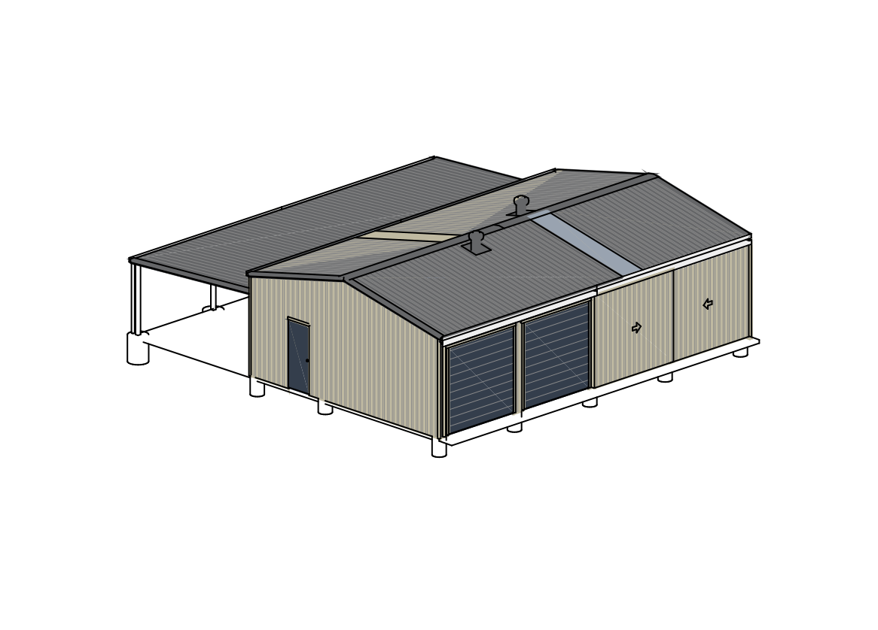

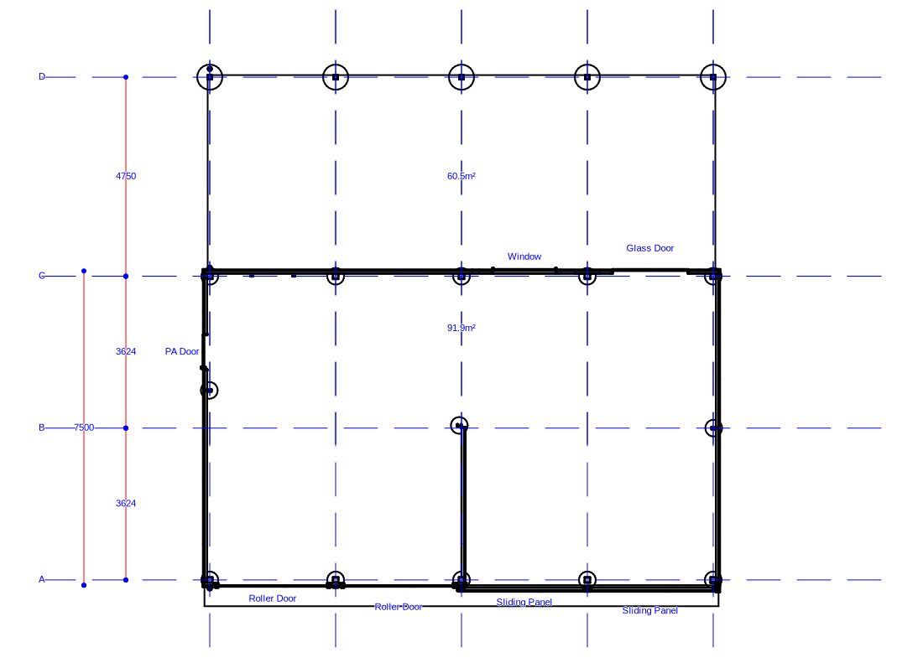
FLOOR PLAN
IMAGE REMAINS PROPERTY OF BLACKBIRD INDUSTRIES
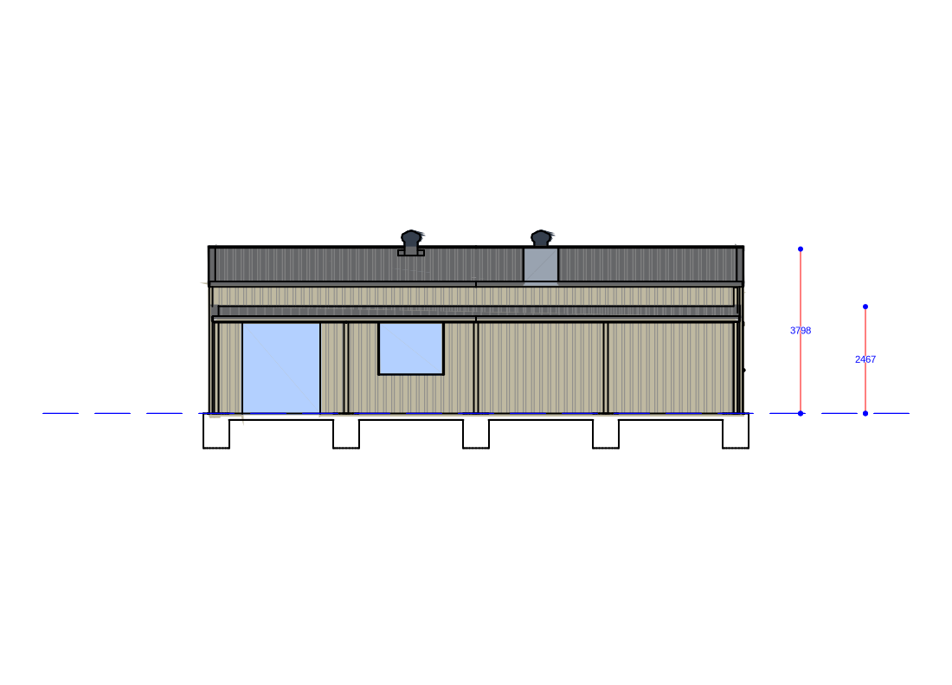
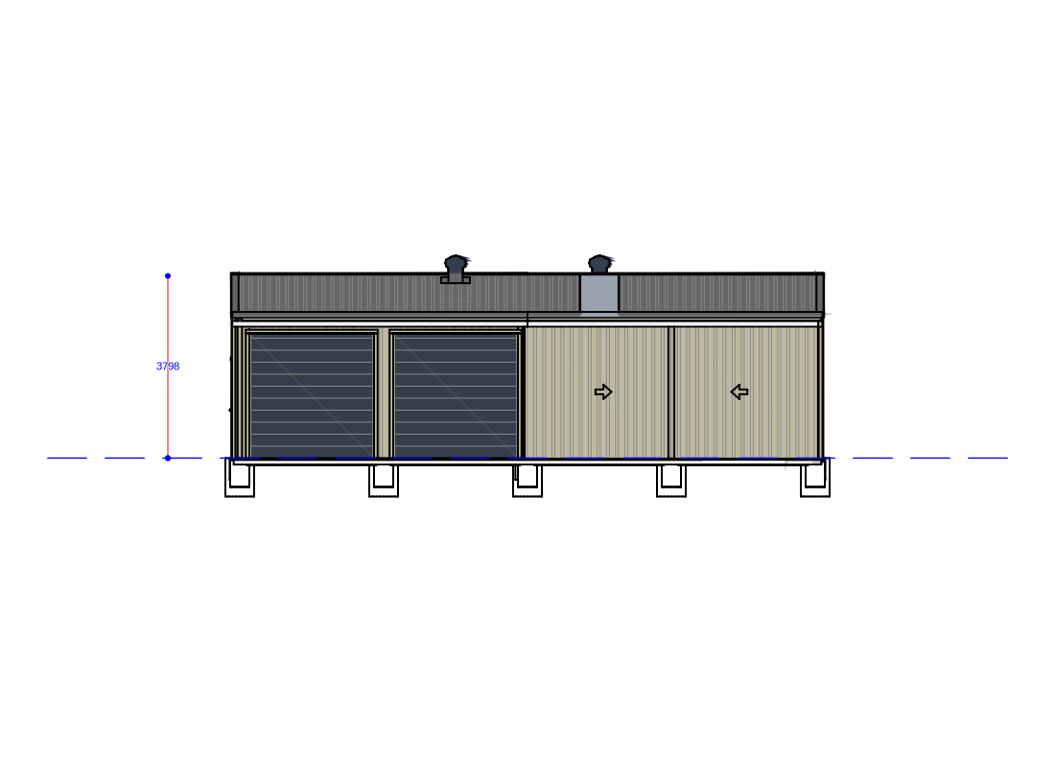
8
ELEVATION 2
ELEVATION 1

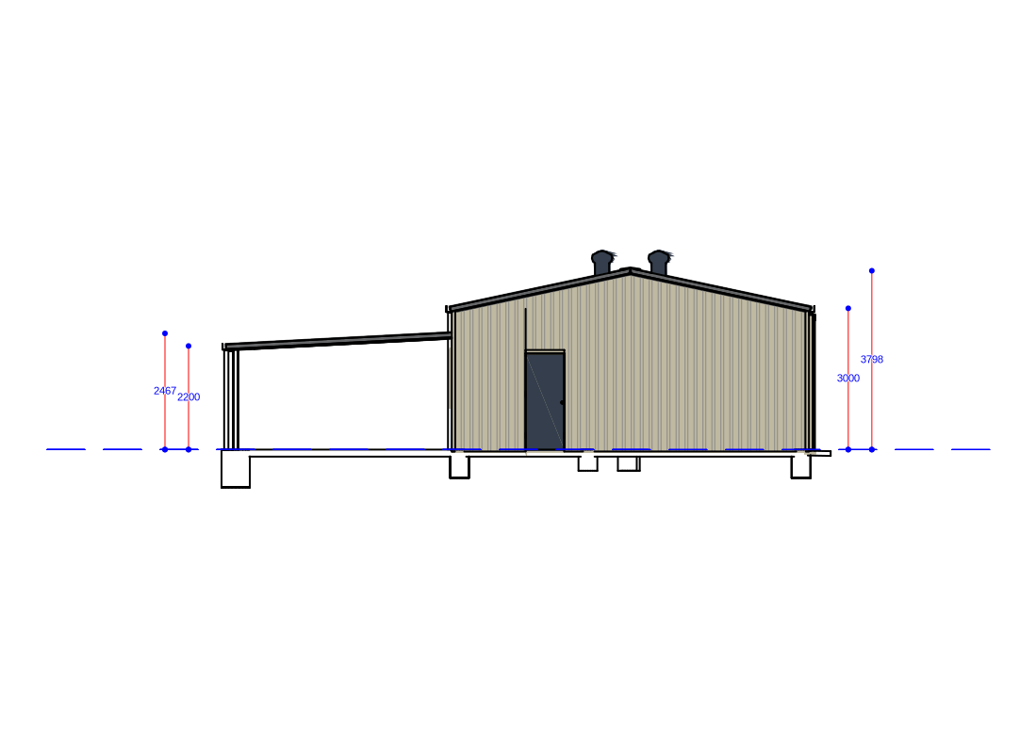
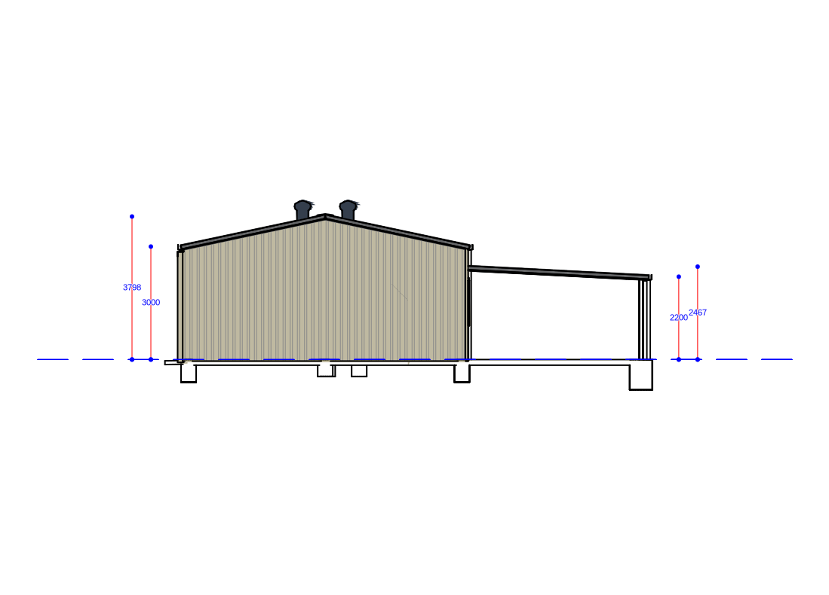
ELEVATION 4
ELEVATION 3

